<<[24] >> <<[month]>> <<[year]>>

Firm Reference: 25-259-00002

Transmitted Online

<<[Client Name]>>

Dear <<Salutation>> <<Client Surname>>

RE: Engagement Agreement – Franchise and Contract Law Services & Advise

You have requested, and Levine Law (the “Firm”) has agreed to provide legal services (the “Services”), in connection with your proposed purchase of an existing franchised business, as set out in this letter.

Thank you for selecting our law firm for this work. The purpose of this letter is to: summarize and confirm the terms of our engagement; describe how services are provided, compensated, and if required, terminated. All services the Firm provides will be governed by the terms and conditions of this letter, unless we specifically agree otherwise.

Confirmation

If you are in agreement, please send back a signed copy of the current page at your earliest convenience and no later than one week from the date of this letter. A digital scan or electronic signature is sufficient.

Thank you. We look forward to assisting you with your important matter(s).

Yours truly

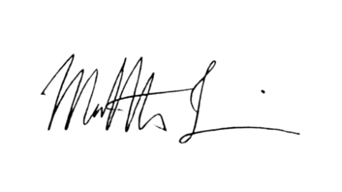
LEVINE LAW

Matthew AJ Levine

